## About PHEMI

PHEMITM Health Systems is a process automation and analytics company that unlocks patient data to improve clinic productivity, patient outcomes, and medical research.

## Logging On

To access PHEMI Healthcare Services Platform (PHEMI), enter the log-in address that was configured during Setup & Installation (typically phemi-central.[yourcompany].com) on your browser.

Enter your username and your password in the appropriate boxes and click “Login”

## Setting Up the System

### User setup & maintenance

Key users of the system can be created and modified through this portal, and assigned one of the following roles: Administrator, Privacy Officer, Data Owner.

* Administrator: Responsible for managing users of the system as well as the configuration.
* Data Owner: Responsible for creating and managing Data Sources and Datasets for export from the system.
* Privacy Officer: Responsible for Access Policies and approval of Data Policies based on data sharing agreements are handled by this role.

### Each user can also be assigned a number of authorizations which control the data they are able to access in the system through Access Policies.

### 

### System Configuration

Dataset destinations and data source connections are configured initially based on the parameters of the connection type (ODBC, FTP, and JSON-REST).

Initial installation and setup of the system will configure all specified source and destination connections. Administrators can update connection details, such as IPs and credentials if these external systems change.

### HANA Dashboard & Analysis

During initial configuration, the HANA system will be configured including the dashboard and Lumira. The dashboard can be accessed via the provided URL and Lumira can be launched with the provided storyboard configuration.

## Data Sources

During initial setup and installation, all specified Data Sources are configured.

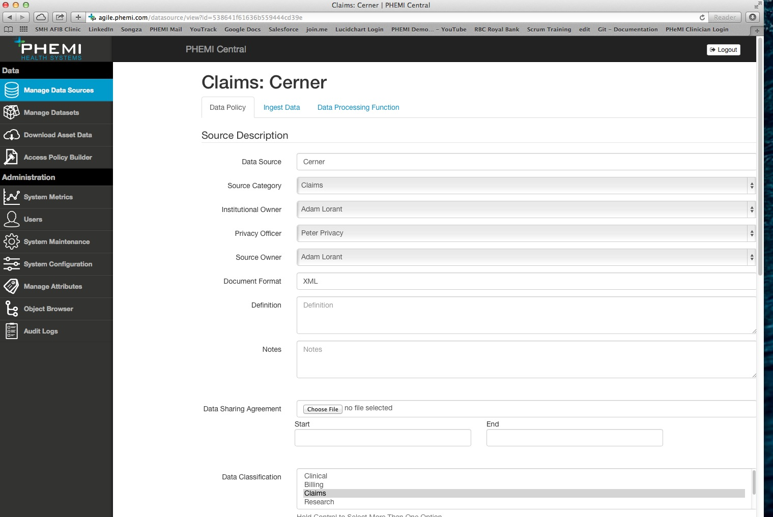

In the event of changes, the components of a Data Source can be altered.

Under Manage Data Sources, the Data Owner can manage details about the data source, classification, retention, encryption, alerts and storage. In addition adjustments to the ingest schedules and data processing function triggers can be made.

### Data Policy

* Institutional Owner – The individual responsible for this data in PHEMI Central.
* Privacy Officer – Responsible for approving Access Policies.
* Source Owner – The data owner who approves dataset requests involving this source.

### Data Ingest

At any point, manual ingest of files for a Data Source can be performed or scheduled triggers can be adjusted.

## Access Policies

Data Owners can create Access Policies by constructing logical rules that combine user authorizations with object attributes for feeding data from PHEMI Central into HANA. Rules are combined by a logical “or” operation that enables a wide range of access policies to be created (eg. A doctor can view identified patient information when logged on from the hospital network).

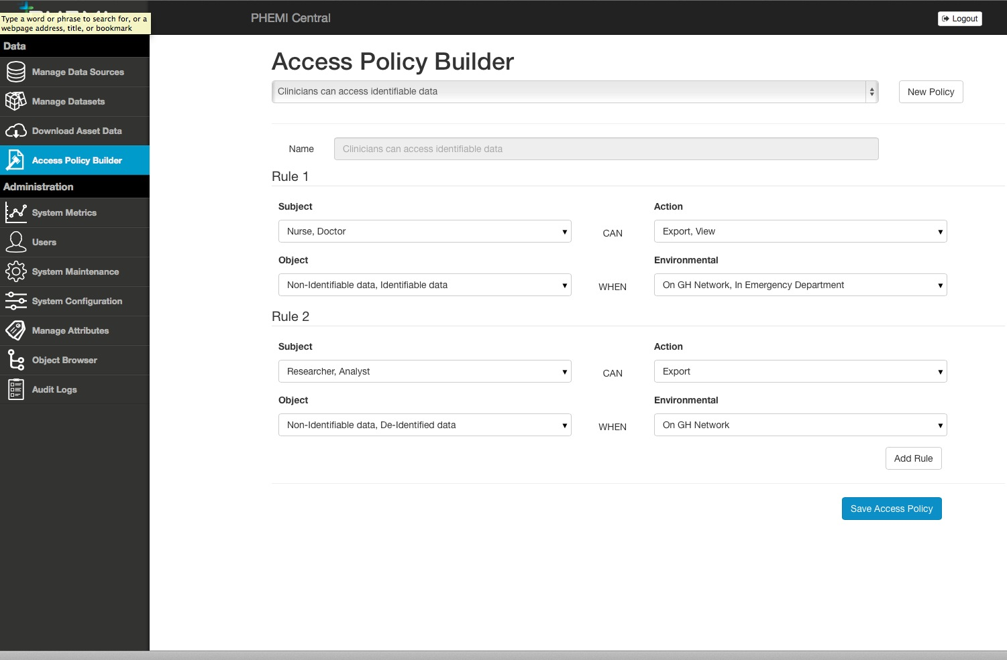

## Managing Datasets

### Build Dataset

A subset of the elements produced by Data Processing Functions are selected to define a dataset that will be materialized in HANA. The chosen Access Policies determine the data representation (e.g. identified or de-identified) that is persisted in HANA.

### Execute Dataset

Execute Dataset allows a selection of Datasets that have been built to be transferred from PHEMI Central into HANA for analysis using the dashboard and analytics environment.

## System Metrics

The System Metrics tab provides system status and health at a glance. The user is also presented with the option to filter based on Data Sources in the system. Metrics displayed include statistics on users, roles, content, sources and storage.

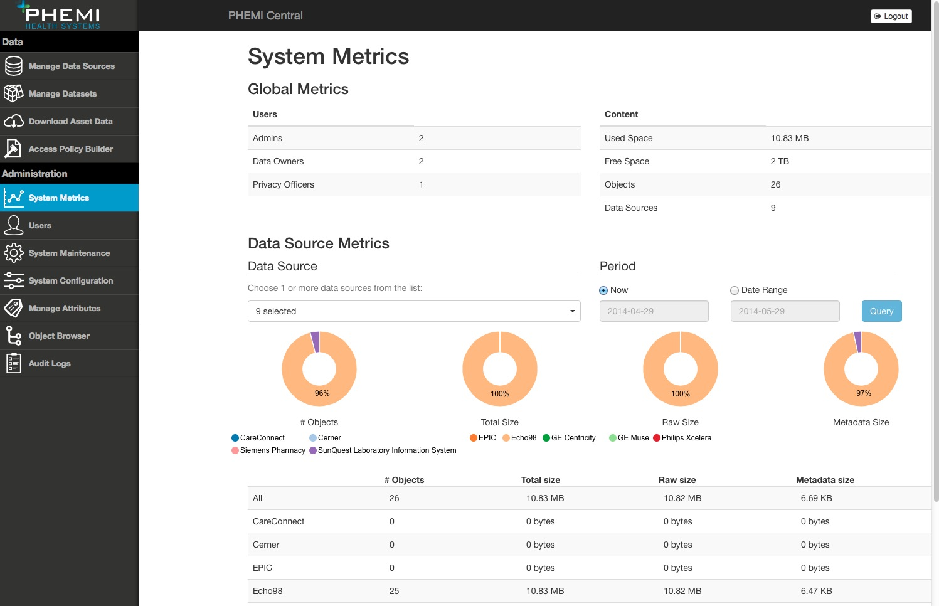

## Key Contact Information / Enquiries

PHEMITM Health Systems - [info@phemi.com](mailto:info@phemi.com)

To view a short video tutorial, please visit http:// vimeo.com/96581198 and enter your provided password.